**Stopping MFP Environment:**

**Step1 - Log in to MFP Ap Server Env and Stop MFP APP Server**

|  |  |  |
| --- | --- | --- |
| 10.224.4.35 | ICTY-4MFPAPP1 | mfpadm |

Stop App Server using the below command:

**/opt/IBM/wlp/bin/server stop mfp1**

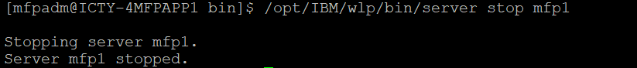

**Step2:Login to MFP DB and Database**

|  |  |  |
| --- | --- | --- |
| 10.224.6.40 | ICTY-4MFPDB1 | mfpdbadm |

Stop the database using the below command.

**db2stop**

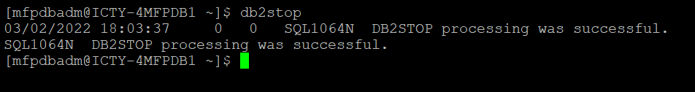

**Starting MFP Environment:**

**Step1: Start Databases**

Start the database using the below command.

**db2start**

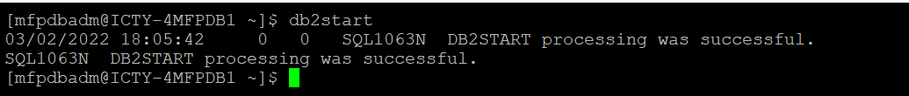

**Step2: Start the MFP APPServer**

Start App Server using the below command:

**/opt/IBM/wlp/bin/server start mfp1**

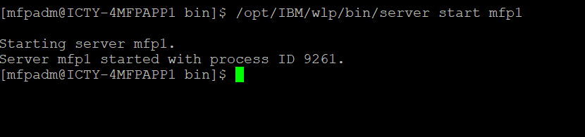

**Validation:**

**Check mfpconsole is up using below url.**

[**https://10.224.4.35:9443/mfpconsole/**](https://10.224.4.35:9443/mfpconsole/)

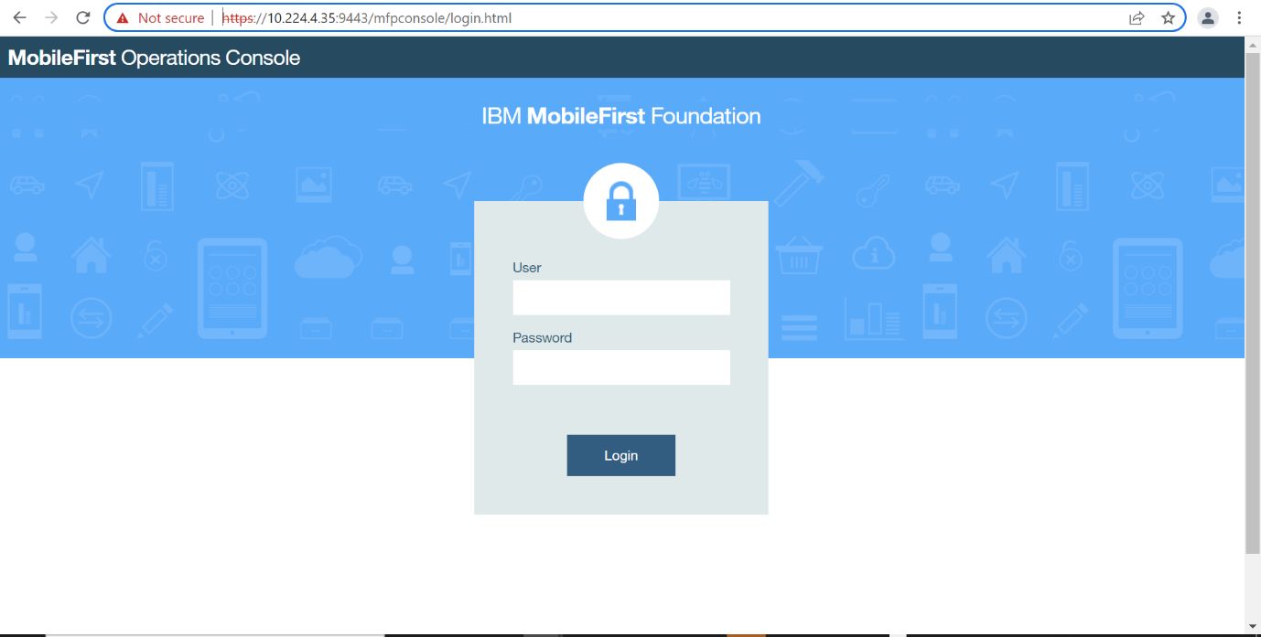

**Starting/Stopping MFP WEB Environment:**

Stop -  **sudo /opt/IBM/HTTPServer/bin/apachectl stop**

Start - **sudo /opt/IBM/HTTPServer/bin/apachectl start**